My First EPUB

Hal Hinderliter
Northern Illinois University
1 December, 2017

Part 1: Welcome to EPUB! 3
First View 3
Do all E-Books use the EPUB Format? 3
Is This a PDF? 3
Who Invented This Idea? 4
Part 2: Benefits 4
Why Should I Choose an EPUB Over a PDF? 4
Part 3: Navigating Within an EPUB 4
Viewing an EPUB 4
Moving Through the Document 6
Jumping From Chapter to Chapter 6
Part 4: Special Features in EPUB Readers 7
Bookmarks 7
Note-Taking 7
Other Possibilities 8
Part 5: Gaining Acceptance 9
Will I Ever See Another One of These? 9
What Issues are Standing in the Way of EPUB’s Wider Acceptance? 9
How Difficult is it to Make an EPUB? 9
Technology Requirements: Hardware 9
Technology Requirements: Software 10
Part 6: Resources for More Information 10
Software for Reading EPUBs on Laptop/Desktop Computers: 10
Software for Reading EPUBs on Mobile Devices: 10
Links to EPUB Developers: 10
More Information on Accessibility: 10

Part 1: Welcome to EPUB!

First View
If you’re reading these words right now, then you must have discovered one of the many ways to view an EPUB. These digital books can be read by using an app for your phone, tablet, laptop, or desktop computer. They can also be read directly within some web browsers (may require the installation of a plug-in).
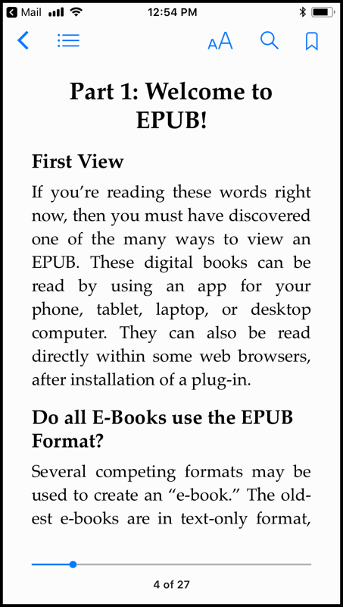
Figure 1: Viewing an EPUB (on an iPhone)

Do all E-Books use the EPUB Format?
Several competing formats may be used to create an “e-book.” The oldest e-books are in text-only format, without navigation or illustrations. EPUBs compete directly with Kindle’s .amz (now KF8) book format. The largest share of e-books, however, have been saved as PDFs. It is my position that EPUB should become the dominant format for the sharing and archiving of stand-alone digital documents capable of being read offline

Is This a PDF?
No! Documents saved in the PDF format have a fixed size, so reading one on a mobile device often means scrolling and dragging across the document. EPUBs are a reflowable document format. Just like web pages, the text can be enlarged or reduced, and can change orientation if you rotate the viewing angle. On many reading systems, the software you’re using can be asked to read the EPUB aloud.

Who Invented This Idea?
EPUB (short for “electronic publication”) is the direct descendent of the DAISY Talking Book, the first electronic book format for readers with visually impairments. EPUB 3.0 is designed to be the replacement for DAISY books, with both sighted and vision-challenged users able to enjoy the same portable document. The EPUB e-book format is an open standard, managed by the International Digital Publishing Forum (which recently merged with the W3C). Unlike Amazon’s Kindle, the EPUB format is a non-profit collaborative effort shared by numerous stakeholders.

Part 2: Benefits

Why Should I Choose an EPUB Over a PDF?
- Accessibility is one reason why many people advocate for the use of EPUB. Since it is based on previous work to develop a digital “talking book” for the blind, EPUB files are compatible with assistive technologies such as screen readers (that speak the text out loud), braille displays, and other ways of making text accessible. EPUB allows both average readers and those with special needs to read the same file.
- A better reading experience on smartphones and tablets is possible because of the reflowable design of EPUBs. Text can be enlarged, reduced, changed to an alternate font, or even reversed out of a black background. No of the zooming, scrolling, and dragging that you’ve experienced when reading PDFs -- it makes reading books as easy as viewing the web!
- Easier navigation makes a difference when you’re reading documents that are long or have many sections. EPUBs always contain a Table of Contents that is easy to access directly from your app’s Navigation menu.
- Search, bookmarking, and note-taking functions vary between reading systems, but are generally effective and easy to use
- Video and audio files can be embedded within EPUBs, adding an interactive spin to the reading process.

Part 3: Navigating Within an EPUB

Viewing an EPUB
Once you’ve installed an app for your smartphone, software for your laptop or desktop computer, your EPUBs should open when double-clicked; after that, you can generally find them in your EPUB software’s Library (or just continue to double-click the file). On a smartphone, you can usually open an EPUB by clicking a link to the file from within a web browser (or the Blackboard app).
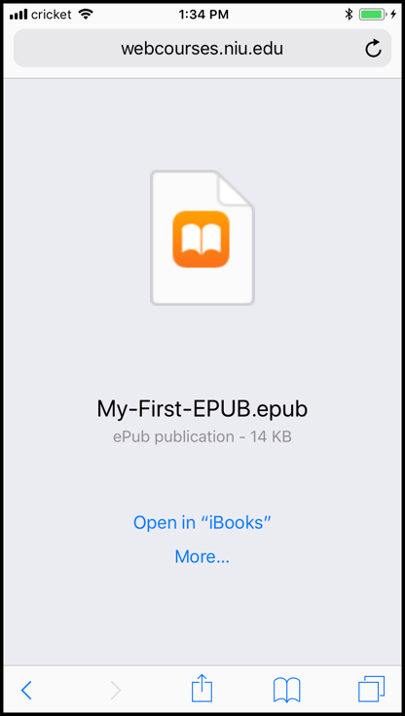
Figure 2: Opening an EPUB in the Safari web browser (on an iPhone)
Alternatively, you can ask someone to send you an EPUB as an email attachment; clicking the attachment should display a list of compatible reader software.
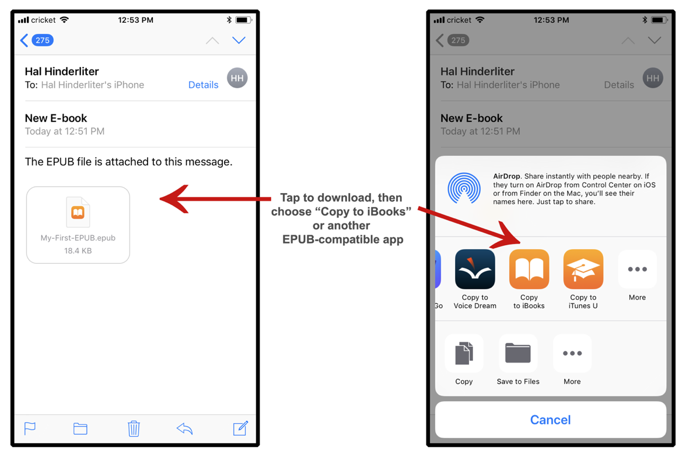
Figure 3: Receiving and opening an EPUB as an email attachment
Older hardware e-readers (such as the early Kindle devices) may require that you use a computer and a USB cable to “sync” the device and transfer the EPUB. Some devices also allow you to add an EPUB by forwarding it to a specific email address associated with that device. (Kindle users can send an EPUB to their device’s email address, and Amazon will automatically convert the EPUB to the Kindle format then load it onto the device.)

Moving Through the Document
When the EPUB opens, your e-reader software or device will typically display the beginning of Chapter 1. For simple documents (memos, letters, short essays), this will be at the very start of the content. For books and long reports, however, the first page displayed will not be the first page of the original document – instead, the “start page” will be the whichever page is designated to be “1.” In these situations, page 1 does not appear until after the Roman numeral page numbers of the front matter (which includes the cover, Table of Contents, Preface, etc.).
Once the EPUB is open, you can move “forward” into the document, which is often represented by the right arrow key of a computer keyboard. On touch screen devices, tapping the right side of the screen or swiping from right to left are common ways to move forward to the next page. Hardware EPUB readers (such as a Nook) may have buttons on the right and left edges of the display that can be pressed to move forward or backward.

Jumping From Chapter to Chapter
One important (but potentially confusing) aspect of using EPUBs is knowing that your e-reader’s navigation system provides an embedded list of links to the document’s defined sections. Because this list looks like a Table of Contents from a book, some e-reader applications call their embedded navigation system the “Table of Contents” or simply “Contents.”
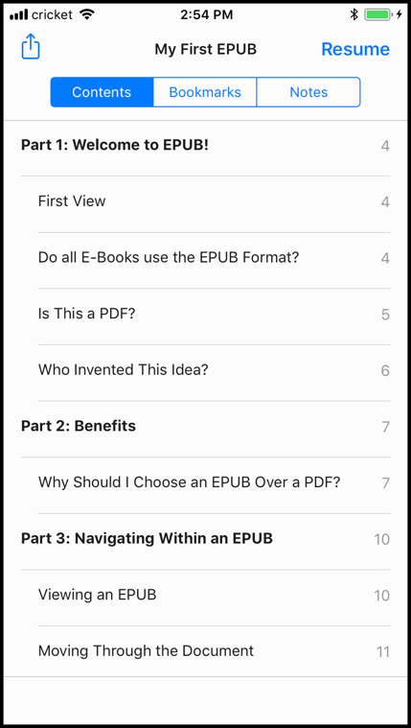
Figure 4: The e-reader's navigation system in iBooks (on an iPhone)
Referring to the e-reader’s navigation system as the Table of Contents (TOC) can be confusing, because books, magazines, journals, and some reports will typically display a TOC for readers to view. When these documents are converted to EPUB, the “visual TOC” is preserved (and works as expected) within the EPUB, but this is different from the TOC provided by the navigation system. In short, your e-reader will allows provide a way to jump between sections (a TOC) that is not shown within the text, but is instead accessed from a menu or button; in addition, an EPUB may contain a visual list of links to sections (which may also be called a TOC). In very simple EPUBs, the navigation system may only contain one link (to the start of the content).
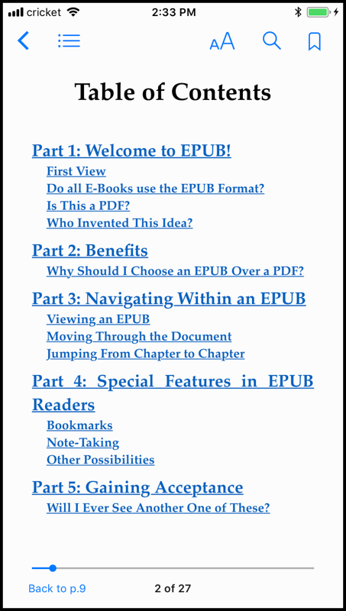
Figure 5: The "visual TOC" generated from the Word document's TOC

Part 4: Special Features in EPUB Readers

Bookmarks
Nearly every EPUB reader will allow you to designate a special bookmark location within the text for quick access. Once you’ve created a custom bookmark, you can find it again by checking the Bookmark menu (often located in the same window as the TOC).

Note-Taking
The ability to create marginal notes (marginalia) on texts isn’t limited to printed books! Most EPUB reading software has some form of note-taking functionality.
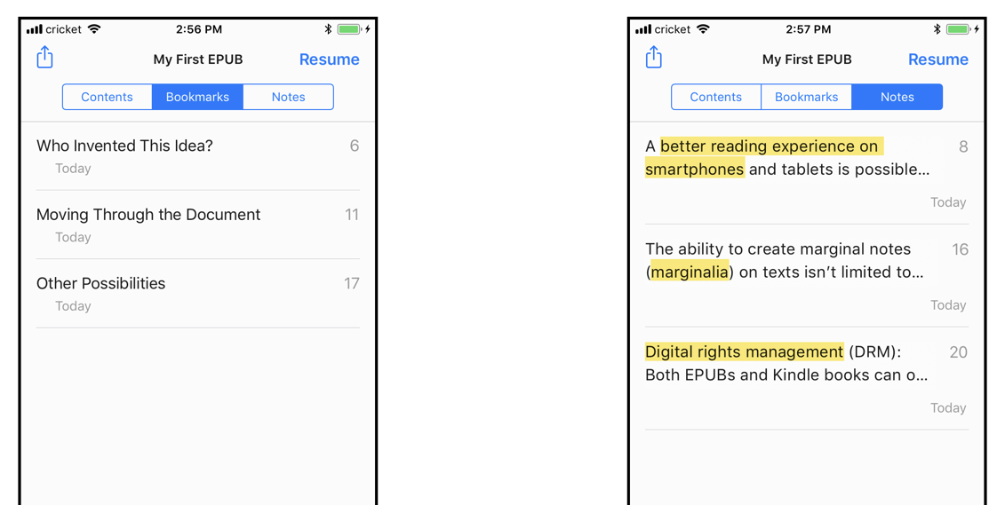
Figure 6: Readers can create their own Bookmarks and Notes (examples from iBooks on an iPhone)

Other Possibilities
- Searching the EPUB’s text for a specific word is supported in most e-reader software, but typically not on older hardware devices.
- Video and audio may be embedded within EPUB documents (can produce large files).
- EPUBs are intended to be compatible with assistive devices (such as refreshable Braille terminals), but some older devices may need to be updated to recognize EPUBs.
- “Read aloud” capabilities exist within most e-reader systems, using a computer-generated voice to convert the EPUB’s text into an audio book! Some apps (such as Voice Dream) will highlight each word in the text as it is spoken, which can be of great value to low-vision readers or neuro-divergent readers.
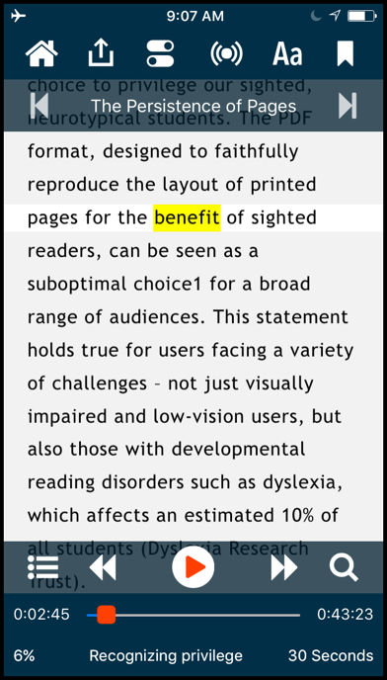
Figure 7: Synchronized highlighting and narration in the Voice Dream app

Part 5: Gaining Acceptance

Will I Ever See Another One of These?
Probably! In fact, if you’ve ever downloaded a book using the iBooks app on an iPhone, iPad or a computer, it was an EPUB. The same thing is true for books downloaded to Nooks (from Barnes & Nobles). School libraries are also starting to include EPUBs in their on-line resources, especially in the case of academic journals. Academic book publishers love EPUB’s ability to be rented for a pre-defined time period.

What Issues are Standing in the Way of EPUB’s Wider Acceptance?
- Page numbers: EPUBs are not numbered in the same way as printed books, which can make classroom discussions challenging if the teacher is using a printed book.
- Digital rights management (DRM): Both EPUBs and Kindle books can optionally be “locked” to a specific device or shared account, but that is rarely the case with PDFs.
- Webtexts: Offering many of the same accessibility advantages as EPUB, the idea that all documents should be a collection of one or more web pages is gaining ground, taking away potential uses for EPUB. Fortunately, most teachers (and all librarians) recognize the need for a stand-alone file that may be archived and used off-line when needed!
- Competition: Amazon is a challenging rival, so the cooperation of everyone within academia is needed to promote open-source EPUB as the superior alternative to the Kindle’s proprietary e-book formats.

How Difficult is it to Make an EPUB?
There are at least four ways to turn Microsoft Word documents into reflowable EPUBs! (Note that the document should make extensive use of paragraph Styles, especially Word’s Heading styles. The document must begin with one or more words formatted as Heading 1, and have been structured through the creation of a Table of Contents; the TOC can be deleted after the structure has been created.)
- Convert the Word document into a GoogleDoc, then export to EPUB from GoogleDocs.
- Upload well-constructed files to an online conversion tool, such as https://www.online-convert.com.
- Import Word documents into Adobe InDesign or QuarkXPress then export to EPUB.
- Pay for the services of a conversion service or publishing consultant.

Technology Requirements: Hardware
EPUBs can be viewed on desktop computers and laptops, but also on mobile devices such as tablets and smart phones. Many dedicated e-reader devices are also compatible with EPUBs, including the Barnes & Noble Nook and the Sony Reader.

Technology Requirements: Software
An appropriate software program is needed to view EPUBs on a computer or mobile device. Stand-alone applications have been typical, but the new ability to view EPUBs within web browsers will likely become a popular option.

Part 6: Resources for More Information

Software for Reading EPUBs on Laptop/Desktop Computers:
Apple iBooks for OS X (pre-installed on Mac computers)
Adobe Digital Editions: http://www.adobe.com/solutions/ebook/digital-editions.html

Software for Reading EPUBs on Mobile Devices:
Apple iBooks for iOS (pre-installed on iPhones and iPads)
Google Play Books (Android & iOS): https://play.google.com/store/apps/details?id=com.google.android.apps.books

Links to EPUB Developers:
International Digital Publishing Forum: http://idpf.org/epub
EPUB Zone is run by the IDPF: http://epubzone.org
Smashwords: https://www.smashwords.com
CreateSpace (owned by Amazon): http://www.createspace.com
Sigil is a free EPUB editing tool: https://github.com/Sigil-Ebook/Sigil
Buy an ISBN for your e-book: http://www.myidentifiers.com

More Information on Accessibility:
EPUB 3 Accessibility: http://idpf.org/a11y
EPUB Zone’s Accessibility - EPUB 3 Resources and Guidance: http://epubzone.org/resources/accessibility-epub-3-resources-and-guidance
The Diagram Center: http://www.diagramcenter.org
DAISY books are the pre-cursor to EPUB: http://www.daisy.org/multimedia

