UDL Design Template
Team:______________________________________________________
Date:_______________________________________
Subject: ___________________________________________

Standard:

Goal: (What do we want all students to know?)

Key Vocabulary:

Assessments: (How will we know they know it?)
Non-negotiables:

Barriers: (What potential barriers do you anticipate students will face?)

Methods: (What lessons and strategies are you going to use and in what order?)

Materials: (What do we need to gather or build?)

Graphics:
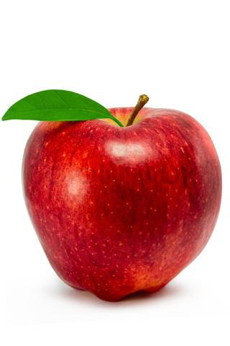
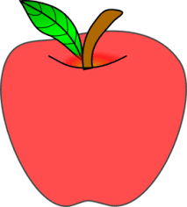
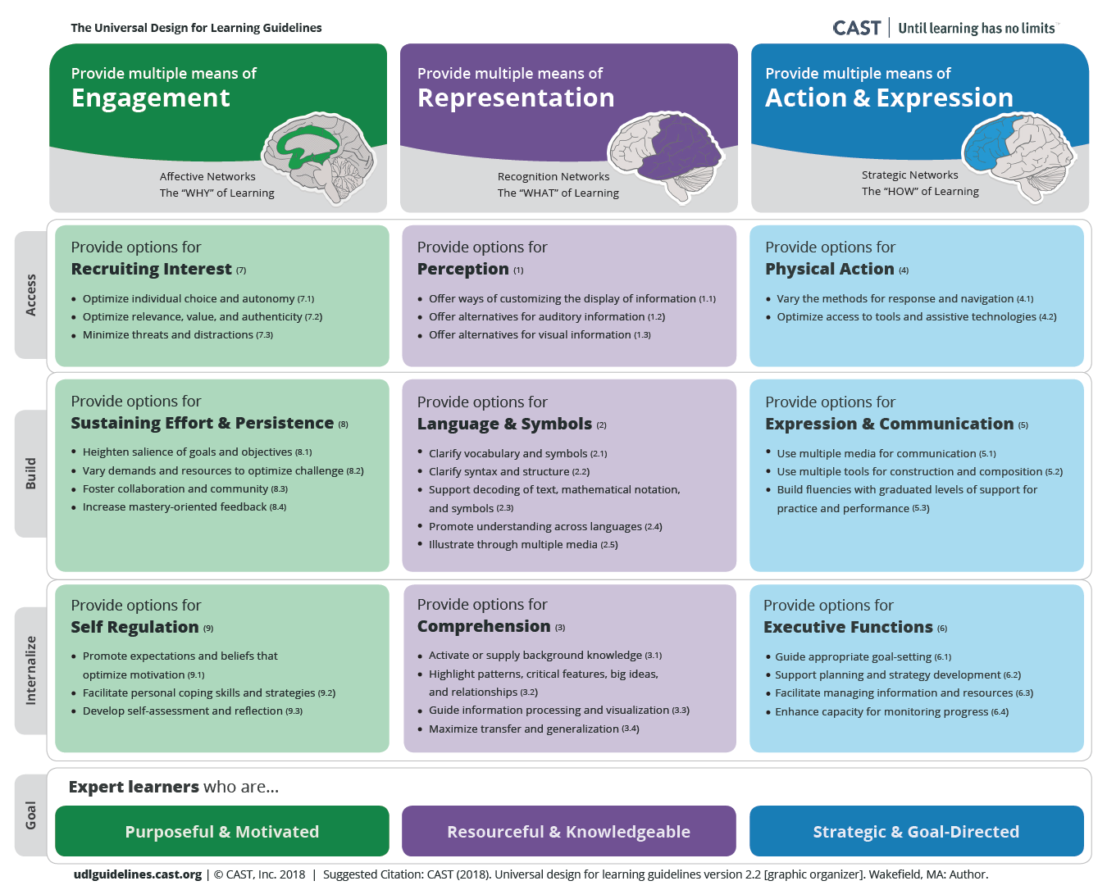
Concrete
Symbolic
Apple
Apple

